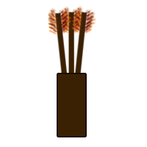
Dragon’s Bane
Daniel Trayler
GAME 1304-1051

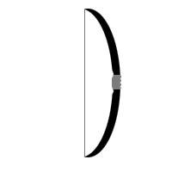

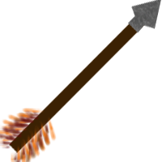

TABLE OF CONTENTS

Backstory … pg 3

Objectives … pg 4

Walkthrough … pg 5

Win and Lose Conditions … pg 6

HUD Elements … pg 7

Enemies Description … pg 8

PickUps Description … pg 9

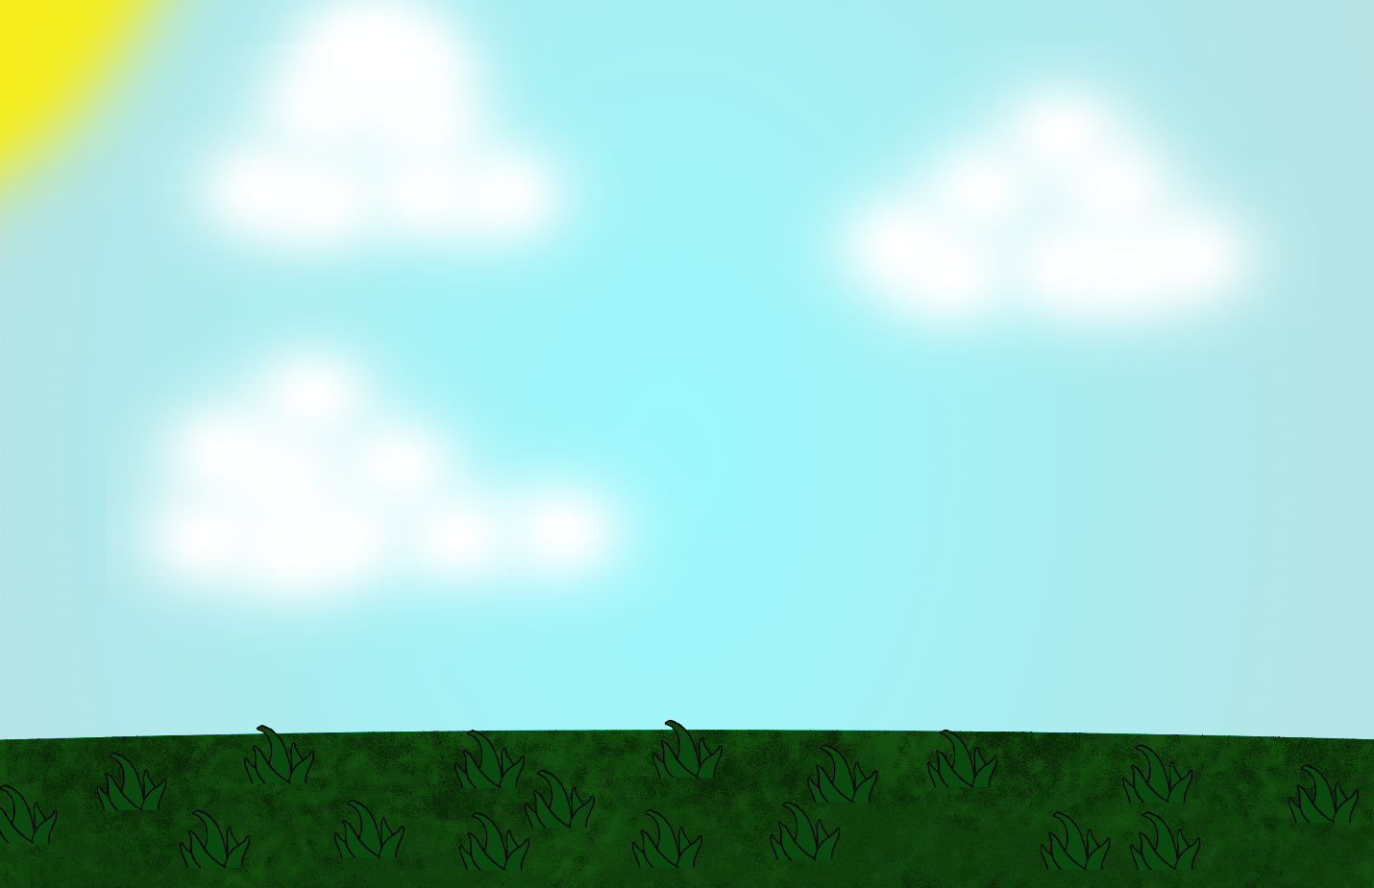

Backstory -
The Kingdom has been peaceful for over two decades. The King has grown comfortable in his duties to the Realm. In doing so, King Arthur has grown lax in his training, allowing himself to become the fitting image of one who eats five meals a day. It is that time of year that he must make his rounds to all of the small villages that border the Kingdom's capital, Camelot. It is on this trip that evil befalls him and he crew of equally chunky men. A band of angry flying dragons have attacked his convoy and taken the King's most valued possession, the mighty Excalibur.

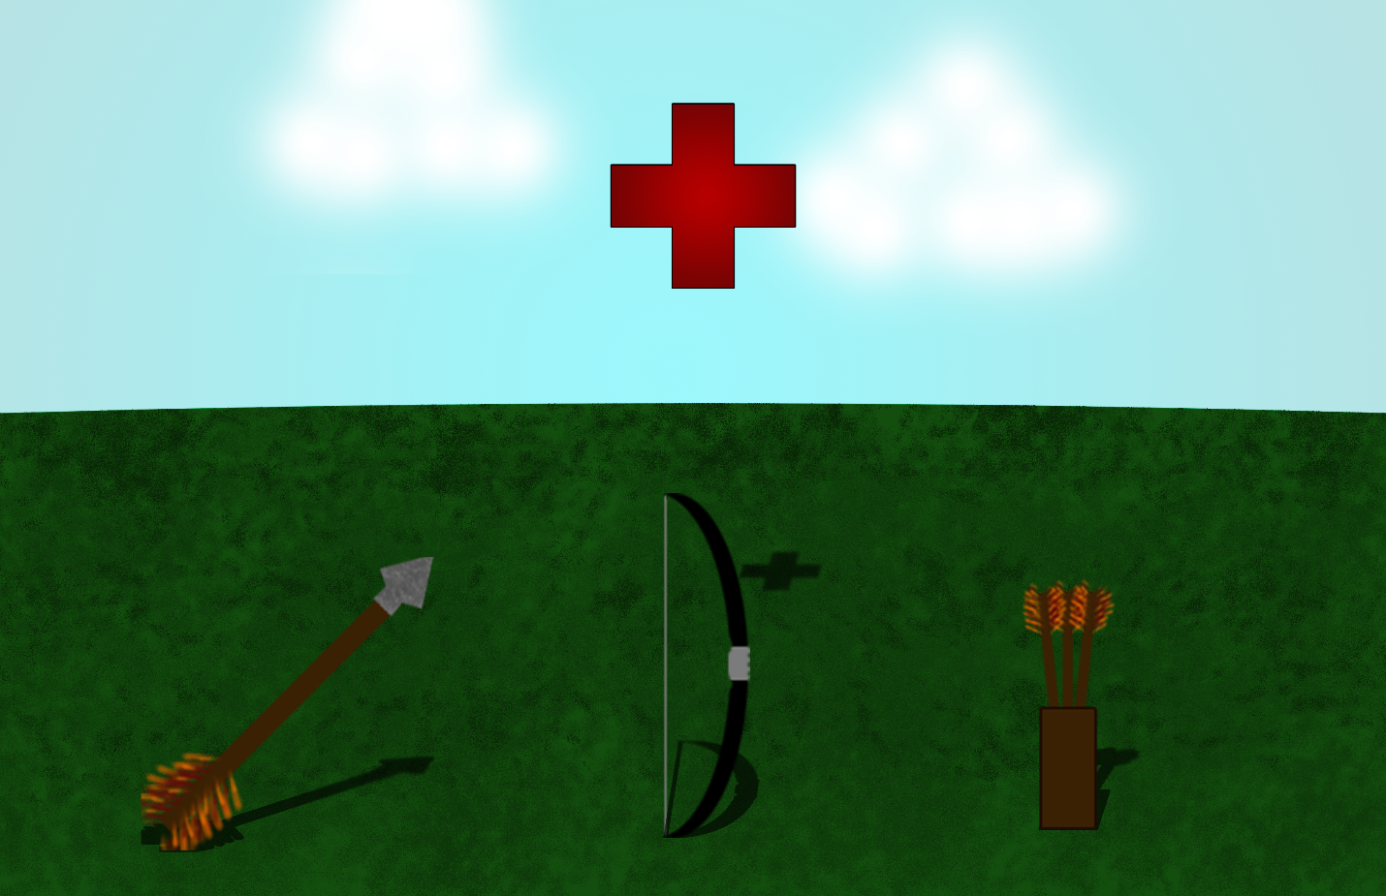

Objectives -
You must play as King Arthur and get his sword, Excalibur, back. To do this you must grab a bow that one of the beasts that attacked your carriage must have dropped. Use the bow to shoot down the flying monsters and make your way up the platforms. You must find the large arrows littered around the platforms. You must gather three of the larger arrows in order to shoot down the vines that hold the gate to the large Dragon you must fight to win back your sword. Once you have collected these three larger arrows, you are able to break the vines that hold the gate up to the large Dragon who holds Excalibur in his grasp. You must shoot the Dragon in his weak spot on his stomach in order to get him to lose health. His scales are too hard to damage him anywhere else.

Gameplay Walkthrough -
The player will start on the bottom left of the level. from here they must move to the right and jump on a platform. here they will find a bow. they must pick this up then jump to the next platform where they will find a quiver of arrows. Now the bow is usable. To the right of the platform there will be a drop-off with lava in a pit below. The player must jump off and use the UP current air flow created by the heat from the lava to move upward. from here the player should move to the left platform. Here will be another ammo spawn point. The player must continue moving left to the next platform. This will be a health spawn point. Keep moving to the left to the last platform available. Here is where the player will find a large arrow. Pick this large arrow item up for later use. move back to the UP current and move to the platform on its right by jumping back into the UP current. This platform will be an ammo spawn point. You must always be wary of flying monsters. One arrow will take care of these enemies, but be careful you don't become overwhelmed by the sheer numbers. Move one more platform over to the right. Here will be another large arrow pickup. Pick this Large arrow item for later use. Move up and to the left platform. Watch out for flying monsters. Keep moving up and to the left. This platform will be an ammo spawn point. Move up and to the left again. This platform will be a health spawn point. Move two more platforms to the left to find the final large arrow pickup. Move back to the right until you reach the ammo spawn point. From this location move up and to the right one platform. This will be a health spawn point. Watch out for flying monsters. Move one more platform to the right. Here you will see the Dragon's Lair Gate. You will see the large vines that are holding it shut. Normal arrows will not damage these vines. They are too weak to do any damage. There is one more platform up and to the left of where you are. From here you will be able to hit the vines with ease. You must right click on the mouse to change your arrow type to the large arrows. You will have three large arrow to shoot down three thick vines. You must hit all three shots in order to move into the Dragon's Lair. Once you hit these three vines, you will be able to go into the Dragon's Lair. Inside of the Dragon's Lair you must use your bow and arrows to hit the Dragon in the head to damage it. The Dragon takes 5% damage from every hit so it will take twenty hit from the player to defeat it. Once you defeat the Dragon, he will drop Excalibur. You will pickup Excalibur and win.
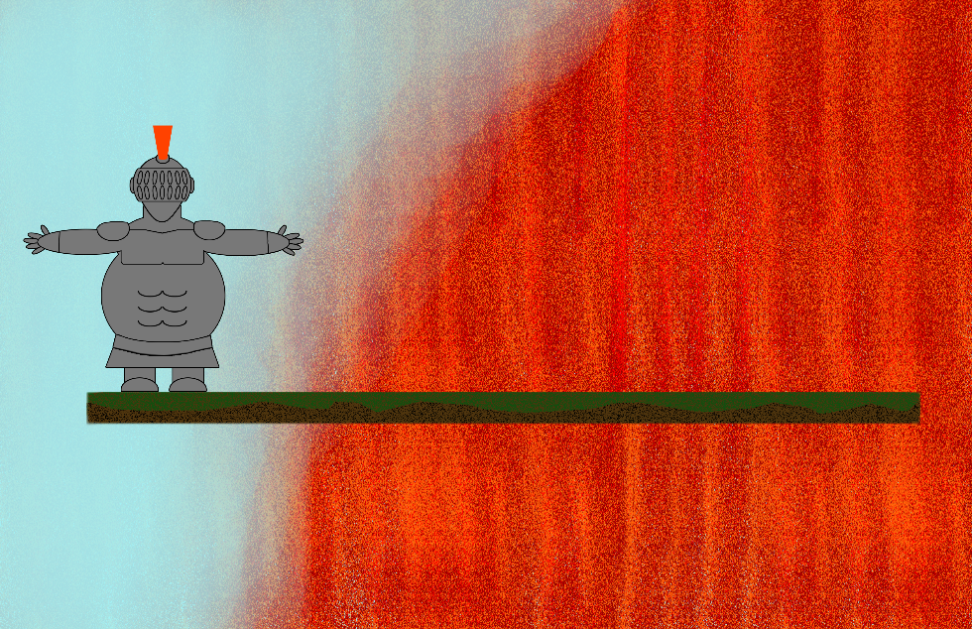
Winning Condition -
The player will win once they pick up three large arrows. They must use these arrows to shoot down the thick vines on the Dragon Lair's Gate. They must avoid and defeat the flying monsters. They will have to hit the Dragon in the head twenty times to defeat it. Finally, they will need to pickup Excalibur. Then they win.

Losing Condition -
The player can fall into the lava and die. The player can touch the lava and die. The player can be hit ten times by the flying monsters and die. The player can be hit three times by the Dragon and die.

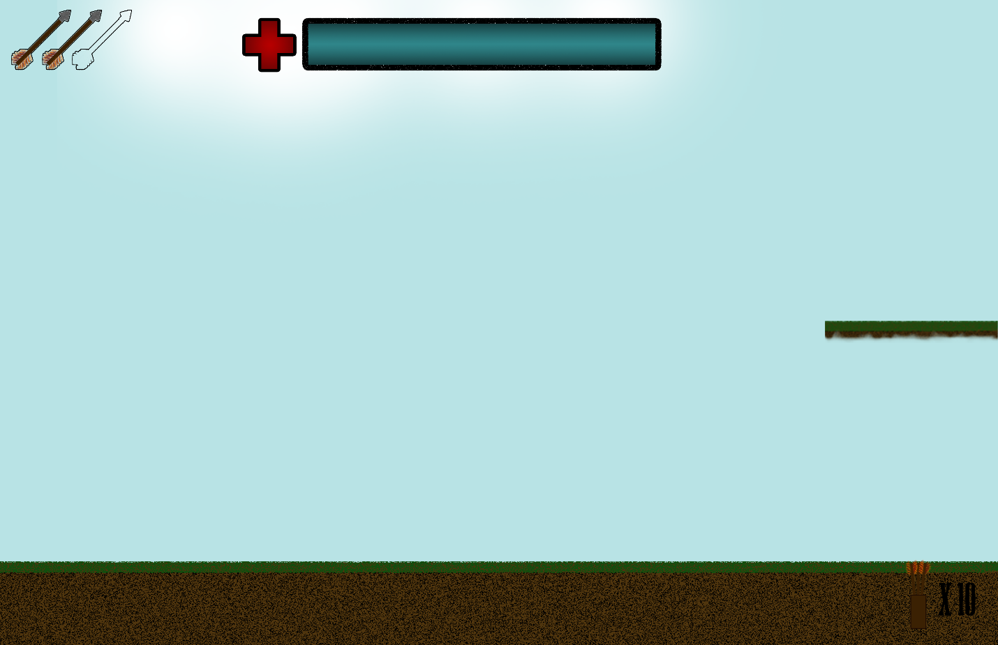

HUD Elements -
Inventory Slots - These inventory slots will be an outline of three larger arrows. You must find the larger arrows on the map in order to fill these slots.
Visual Health Indicator - This will be a blue health bar on the top of the screen. It will also have a red cross indicating health to the left of it. This will be a blue health bar when full and as it goes down will reveal a red bar.
Visual Ammo Indicator - This will be a brown quiver with a black number by it that will indicate how many arrows are still available. The quiver color will also go down depending on how many arrows are available.

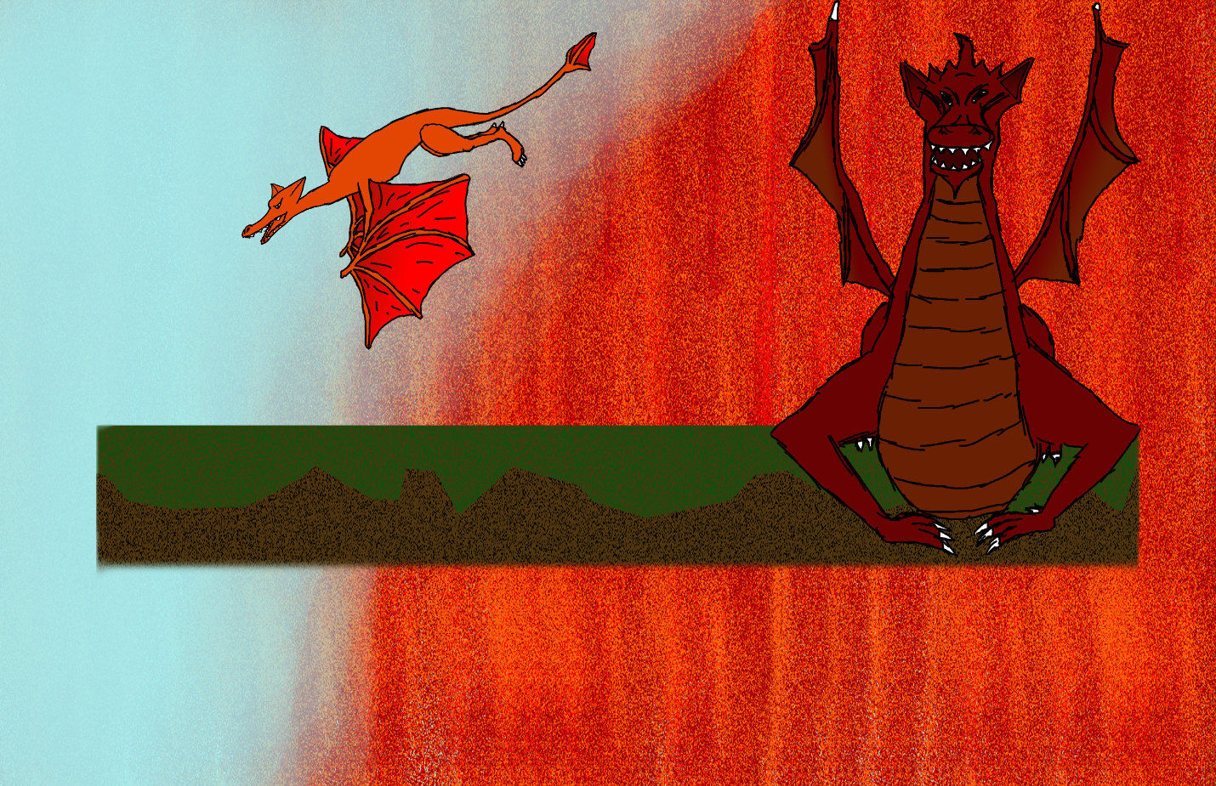

Interactive Elements -
Attacking Enemies with A.I. - These enemies will be a flying monster that will swoop down on the player dealing damage on contact. They will be represented with an orange pterodactyl-type monster. They will take away 10% damage upon hitting the player. They will take 100% damage from the player's arrows.
Attacking Enemies with A.I. = This enemy will be the final boss Dragon. It will be represented by a large red/orange Dragon. It will be able to shoot fireballs when the player reaches the Dragon's Lair. It will be able to inflict 40% damage on the player with one fireball. The Dragon will have one weak spot where the player will be able to inflict damage. This weak spot will be located on the Dragon's head. It will be in the shape of a diamond. It will be bright red in color. It will take 5% damage with each hit.

Ammo Pickup - The ammo pickup will be a brown quiver with small arrows in it that will spawn on the platforms. The player will start out with zero arrows so they must hit this pickup in order to get any arrows. This pickup gives the player ten arrows every time they hit this pickup. The player can only hold ten arrows at one time.
Health Pickup - The health pickup will be the same red cross with a black outline that will be to the left of the health bar. This will give back 100% of the player's health when hit.
In Game Pickups - This will be large arrows with orange/red feathers on the end and a silver tip and a wooden stem. These will fill outlines on the GUI with the same image as they are represented with in the form of a pickup. These are capable of slicing through the strong vines that hold up the Dragon's Lair Gate.

